How to Become an IT project manager???
Let’s talk about how to become an IT (Information Technology) project manager.

How to become an IT depends on their career path. If someone starts in IT they could be a techie or they could be some other role in IT already, so they have an interest in project management. They could also be from the non-IT meaning they could be in a different business unit like operations, marketing, or even finance and they could be project managers for those types of projects or they could be some other role. They could have an interest in becoming a project manager in IT.
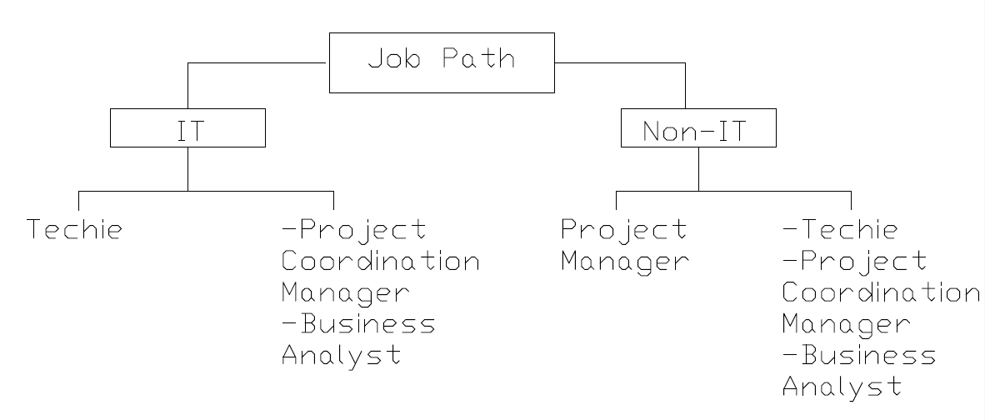

Job Description
Let's look at some common skills and qualifications that companies look for. The Job description is that the project manager should oversee the process of planning, executing, and delegating responsibility around the organization's IT pursuits and goals.
Job Skills and Qualification
The job skills they look for is someone with technical management and technical understandings. They want to make sure that the project manager has an understanding of how the hardware or the software the infrastructure may be networking security all fit together.
They also want to make sure that the person can analyze information because in IT there's a lot of data metrics that go. So they have to be able to take that information and glean insights for the project.
They also need to be good at communication with others because typically on IT projects there are different types of things again people working on the infrastructure the software, the hardware, etc. that have to integrate and communicate.

Staffing, Problem-solving, Datacenter management, and knowledge about advanced project management tools for resource planning and advanced scheduling feature.

Career Path
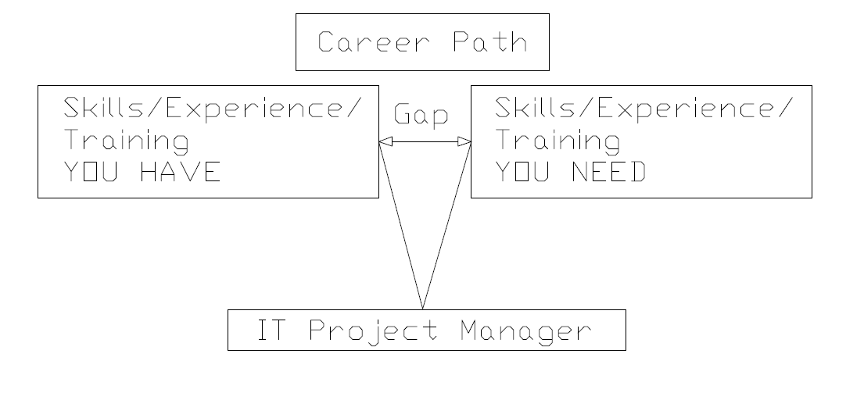
When you're looking at the career path, how to get there, you want to look at the skills experience, and training that you have already and you want to compare that to an IT project manager of specific types of projects you're interested in working in. Look at the specific skills experience and training that you need or are required and with that, you find the gaps. Reduce that gap by making a plan, like training.

Training
You will need project management training. You will also need specific IT training like IT Project Management Training, ITIL, ITSM, etc.

IT project management training dealing with technology-specific understandings (how to manage projects around infrastructure hardware, software, networks, security, etc.)
ITIL stands for Information Technology Infrastructure Library. It's not project management. It is the best practices used to develop and execute IT Service Management for the company.
ITSM is Information Technology Services Management. It's about how you deliver end to end IT services within a company.

